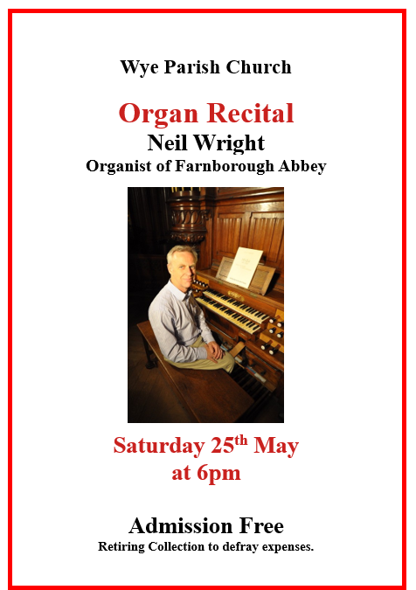

Contact:
United Wye Benefice, Office 2, Zealds House, 39 Church Street, Wye, Ashford TN25 5BL
Tel: 01233 813793 Email: offfice@wyebenefice.org.uk www.wyebenefice.org.uk
Wye PCC is a registered charity. Charity Number: 1135099

Please submit any notices to the office by 9am on Wednesday
Office Hours: Monday to Friday 9.30am–1.30pm.

Church Notices

Sunday 28 April 2024
The Fifth Sunday of Easter

Collect
Almighty God,
who through your only-begotten Son Jesus Christ
have overcome death and opened to us the gate of everlasting life:
grant that, as by your grace going before us
you put into our minds good desires,
so by your continual help
we may bring them to good effect;
through Jesus Christ our risen Lord,
who is alive and reigns with you,
in the unity of the Holy Spirit,
one God, now and for ever. Amen

Readings: Genesis 22. 1-18, Acts 8. 26-end, John 15. 1-8

Please pray for Julie Blyth and Tana Harris.

Petham, Waltham, Elmsted and Hastingleigh. The next 9.30am group service will be Sunday 5 May at Petham with Rev Dawn Stamper. The new service pattern for the Stone Street Group will start from June.

Memorial Service for Sally Lancaster – 2pm on Tuesday 30 April at St Gregory and St Martin’s followed by tea and cake in the church.

Our Place Wye Community Lunches. The next date is Wednesday 1 May and then 15 and 29 May. 12.15 to 1.30pm in the village hall. Food served at 12.30pm. Contact Richard Sinden 07969 583 920 to book a place or to arrange a lift.

Exeter Cathedral Bellringers will be visiting Wye Church on Saturday 4 May from 2pm to 5.30pm. Please be aware they will be ringing continuously for about 3 hours.

Baptism of Noah Lewis on Sunday 5 May at 12.30pm at Wye Church.

Baptism of Evie Blackburn on Sunday 5 May at 1.30pm at Wye Church.

Celtic Evening Prayer Sunday 5 May at 6.30pm at Wye Church.

Options Club – There will be no Options on Mondays 6 and 27 May.

Bank Holiday Monday 6 May – Benefice Office will be closed.

The Five Church Walk (40th Anniversary) is on Bank Holiday Monday 6 May. For more information: https://www.thefivechurchwalk.co.uk/

Baptism of Margot Smith on Monday 6 May at St James the Great, Elmsted with the Reverend Edwina Wallace.

Wye Churchyard Gardeners – Saturday 11th May between 10am and 11am – come and join in with our next churchyard gardening session when we will be getting the churchyard ready for the summer plant sale on Saturday 18 May. An opportunity to meet and chat with friends while tending the churchyard. Please bring gardening gloves, gardening tools (e.g. strimmers, shears, secateurs, hand forks and trowels) and of course garden rubbish sacks to take waste away for disposal. No gardening experience required, just a willingness to keep our churchyard looking beautiful for all to enjoy.

Ashes Burial of Eve Billing on Sunday 12 May at 12.45pm at Wye Church.

Stour Music Rehearsals begin again this year at 7.15pm on Thursday 16 May. Every Thursday through to 20 June at Wye Church.

Baptism of Charlotte Catt on Sunday 19 May at 12.30pm at Wye Church.

Organ Recital with Neil Wright at Wye Church at 6pm on Saturday 25 May (see back page). This is the first of several recitals booked for this year – look out for information in future notice sheets.

Bank Holiday Monday 27 May – Benefice Office closed.

